The School Biotope Aquarium

Aquarium Manual and Maintenance Guide
A guide for aquarium educators, students and keepers.
A resource about biology, physics, chemistry and mathematics.

Prepared by Dave Wilson

Table of Contents
Introduction 4
Hardware 7
Substrate 7
Water Quality 8
Hardness 8
Temperature 8
Carbonate hardness 8
pH 9
Water changes 9
Aquarium set up and establishment 9
Plants 10
Fish 17
Invertebrates 25
Maintenance Plan 27
Problem Solving 29
References and further reading 31
Appendix 1 33
Appendix 2 38

Introduction
Planted aquariums that have a pleasing aquascape and nice attractive aquatic animals are not only a pleasure to look at but are a very good learning tool when it comes to natural process that drive life on earth. Providing the necessary conditions, foods and fertilisers will give you an idea of how delicate our aquatic systems can be as well as instill a sense of responsibility when completing all the chores on the maintenance schedule that are necessary to maintain the aquarium at its best.
The challenge with an aquarium in a public place that can have many masters is to have communications to a levels that the operation appears that there is only one operator. This required a team effort and can be another aspect of the use of the aquarium as an education tool.
Using the plants and animals from one location to replicate a local habitat is called a biotope aquarium. This type of aquarium is becoming quite popular as more people take an interest in their environment. Below are some examples of native Australian biotopes from various habitats in the tropics.

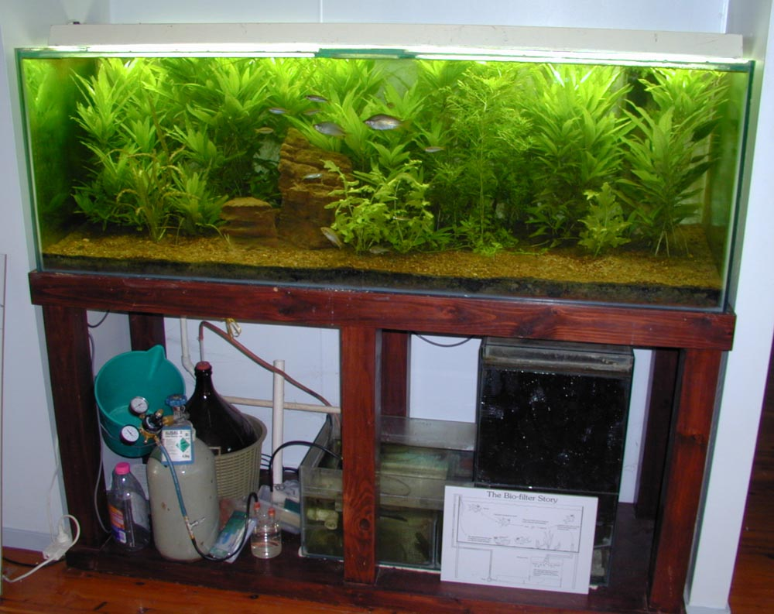
The pictured aquarium was established at the Territory Wildlife Park’s Education Resource Centre during the 1990’s by Kate Smith. It was designed and set up by the author and managed by Kate using a management schedule. The aquarium demonstrated several aspects of water quality and life form management. It had plants from the Daly River locale and carbon supplied from a carbon dioxide cylinder pictured. The first carbon dioxide system was a yeast reactor (still visible, as the big brown bottle in the beige coloured basket). This system was adequate but time-consuming and messy to maintain. The aquarium was then converted to commercial carbon dioxide as noted by the pale green bottle from a local gas supplier that is visible in front of the old system.

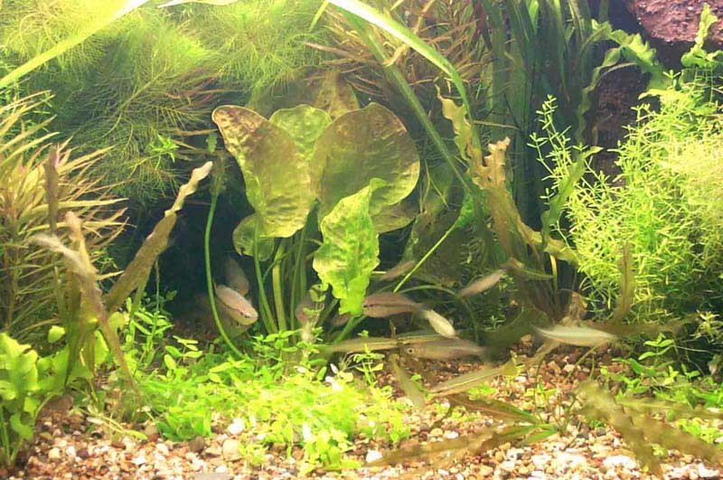
This aquarium was set up to demonstrate how nice an aquarium can be with plants from only one location. All the plants in this aquarium were from the Howard River, NT. The Aquarium was an entry in the Royal Queensland Show, the Ekka, and it took second prize in the Australian Native Aquarium competition.
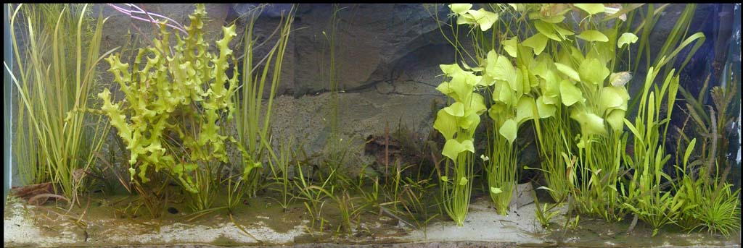
A selection of plants from various escarpment habitats in the NT, not just one particular place made up the plant life in this aquarium. It was set up at the author’s house for experimental purposes.

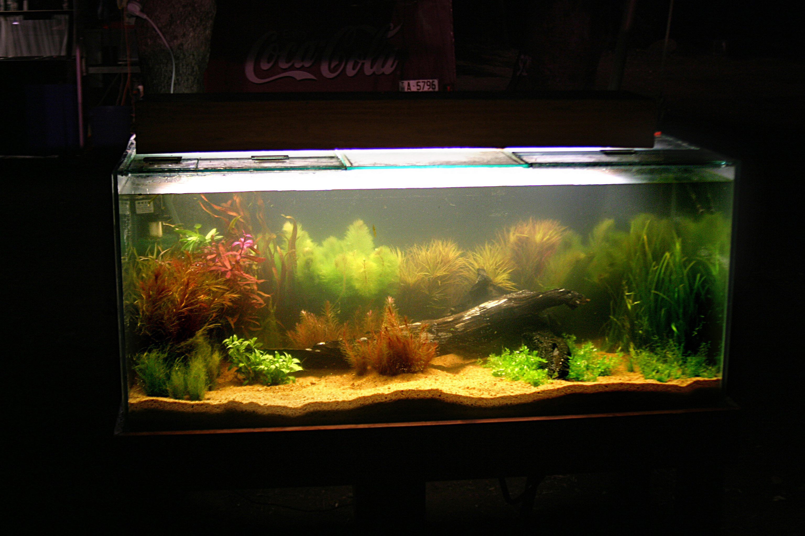
The Aquarium pictured above was used at the Fred’s Pass Show by the Department of Primary Industries (DPI) to demonstrate the beauty of native aquatic plants. It uses plants sourced from various locations around Darwin. It was set up by the author to help the Aquatic Pest Management Unit demonstrate to aquarium hobbyists that there are native plant alternatives to exotic plants.

The Werenbun Association supplied an aquarium and Aquagreen donated aquatic life native to the Werenbun area to help produce a Biotope Aquarium representative of a small part of the peaceful underwater aquatic life from the Mary River District. The replication of the native environment will produce a pleasing aquascape where the aquatic life can live its life as though it were still in the river but without the constant threat of larger predators that would use it as food.

As an educational resource an aquarium can be used to demonstrate many aspects of our natural world. For example, observing the physical manifestation of photosynthesis - when oxygen bubbles form on living, submerged aquatic plant surfaces after the application of a light source. Studying the chemistry of water is another aspect of aquarium maintenance which can give the operator an appreciation of what is required to keep life forms displaying natural behaviour. Chemistry knowledge and mathematics skills are also used when performing maintenance procedures, these will be discussed later.

There is even aquarium philosophy discussed in Spotte (1992). In his book he discusses the curiosity of the general population of what lies beneath the waters. The art and science behind representing a small section of aquatic habitat and keeping it in good order.

The process described in subsequent chapters is designed to assist with the production of an aquarium that will be able to support a variety of aquatic life that will be found in a particular area. The area selected for this aquarium is the vicinity of the Mary River at the Southern end of Kakadu National Park. This area is where the traditional owners are represented by the Werenbun Association and assisted by the Jaywon Association.

Hardware

For the Mary River set up a Jebo brand glass Aquarium with the dimensions 1500 mm by 600 mm by 500 mm with built in lighting was used. There was also A a wooden stand painted black to support the aquarium and a black hood to give it an aesthetically pleasing look. The volume of this aquarium is calculated to be 450 litres.
Incorporated within the hood were filters and lighting. Lighting consisted of three, 40 watt fluorescent tubes and there was a small pump that lifted the water to a built in container containing Dacron wool and other bio filter media. The water is returned to the aquarium where a water diffuser directs the water across the aquarium.

Substrate

The substrate is the soil and gravel on the bottom of the aquarium where the plants can take root and grow. It is an aquatic potting mix that will help with plant growth and water quality. The mix is made of substances that are found naturally, such as shell grit, peat, laterite and sand. Shell grit is a source of calcium, carbon and some trace minerals. Peat is a source of carbon and increases cation-exchange capacity of the soil, this helps the plants take up the nutrients and carbon. Laterite soil and sand also hold it all together and are a source of minerals and nutrients for the plants.

The preparation of the substrate consists of putting a 50mm deep mix of equal parts of soil, sand, peat and shell grit in the aquarium first, then a 50mm of Mary River sand on the top to stop too much water becoming discoloured from the soil. If gravel vacuuming and other maintenance operations are conducted carefully the water will remain clear.

If another type of habitat with low nutrients is being represented then the shell grit can be left out of the mix. An example of a place where this may be found will be on top of the sand stone escarpment where nutrient levels are low and plants from these locations tend to die if surrounded by too much fertiliser.

Water Quality

Water quality is very important. It is the factors in the water that can change and cause stress to the aquatic life in the aquarium. We measure the physical and chemical properties of the water to form the basis from which we make decisions about the adjustments to the water quality.
The water properties that need to be measured are temperature, hardness, carbonate hardness and pH. Once we know what these factors are we can manipulate them to make the water quality better for the aquatic life - plants, fish, crustaceans and molluscs.
Temperature – is the degree or intensity of heat in the water measured in degrees Celsius with an alcohol filled glass thermometer or digital thermometer.
Hardness – is a measure of the dissolved salts of calcium and magnesium in water and is measured simply by a reagent test kit that will give a reading in parts per million or degree of harness. The test kits made in Australia use part per million that is abbreviated to PPM.

Carbonate hardness – is the measurement of carbonate and bicarbonate material dissolved in the water (also known as alkalinity or buffering capacity) and is a measure of the resistance of the water to changes in pH. It is an important measurement for aquatic plants as some water plants have the ability to take their carbon requirements from the bicarbonate in the water thus altering the water chemistry.
pH - is the measurement of the acidic or basic quality of the water and is usually measured with a reagent test kit or electronic meter. The pH is altered by altering the carbonate hardness or by adding carbon dioxide if the mechanism is available.
There are other water quality measurements that tell us the pollution levels caused by the waste products of the fish, shrimps and crustaceans. These animals produce ammonia, which is then changed by bacteria to nitrite and nitrate, (animals also produce phosphate). These pollutants are from the fish, shrimps and snails that excrete their waste in the water.

Water changes – are ongoing to slow the accumulation of the waste in the water and to replace some of the minerals depleted by the aquatic plants. A 20-25% water change is conducted each week. Never replace all the water as you will disrupt the beneficial bacteria colonies that have grown and are essential for a healthy aquarium. These water changes are done at the same time as the other weekly routine aquarium maintenance operations. When using the Estimative Index fertiliser system to run a planted aquarium, approximately 50% of the water is changed each week. This resets the aquarium for the next week of fertiliser dosing.
Estimative Index is a system to use mineral fertilisers to make plants grow. It requires all of the minerals required for plant growth to be overdosed slightly each week then at the end of that week a large water change resets the aquarium. If there is an overdose that is left it can lead to algal bloom. Estimative Index was developed by Tom Barr a planted aquarium expert located in the USA.
Water Change weekly maintenance procedure.
- Turn off all the power except the lights.
- Clean the viewing glass.
- Remove any dead leaves, trim plants where required.
- Use gravel siphon to remove detritus
- Refill aquarium with prepared dechlorinated water.
- Prepare water for next week’s water change.

Aquarium set up and establishment

Make a plan first. Draw some sketches and make some notes about the area where the fish and plants come from (such as water quality parameters, habitat and local environment). It can be discussed among the participants of the project. If possible to take a trip to the location that is to be copied and conduct a survey of the plants and small fishes that will be part of the finished display aquarium.

Next is deciding on where to put the aquarium. Site selection needs to consider access for servicing, amount of natural sunlight received and whether or not there are drafts (either hot or cold). Make sure servicing can easily be conducted and the aquarium can be viewed by the maximum number of persons. The height of the stand is selected by the size of the aquarium and whether the tank is viewed by people in a sitting or standing position.

Access to services such as water and power is a consideration when deciding on the placement of an aquarium.

Plants

Lighting
Plants require light of sufficient intensity to make photosynthesis occur. The light also needs to be on long enough for the plants to produce enough sugars for growth.
Lighting photo period
We are also concerned with the lighting period. This is done with the use of a timer that is set to 10 or twelve hours, coming on when the aquarium is first likely to be viewed, about 8.30 or 9.00am for a school. The photoperiod is important to plants and animals so they can have close to a normal life. The plants need ten hours so the lights can be turned off at 6.30 or 7.00pm.
Light Colour temperature
Another important measurement for the light is the colour temperature. Colour temperature is the colour of a theoretical black ball when heated to certain temperatures. The temperature is measured in degrees Kelvin and a lamp with a Kelvin rating of 6,500 degrees to 8,000 degrees K will look natural as well as providing good light for the plants.
Light intensity
It is difficult for the aquarium keeper to measure the lux falling on the plant surfaces without an expensive meter. One simple way to measure light is by the power output of the lamps. Generally about one watt per litre is good for a high light requirement aquarium and 1 watts per litre. This means that around 450 watts will be required for the school aquarium. Currently there is about 120 watts that is insufficient light intensity. There may be some high intensity lamps available for the fittings in the hood.

Important note: when buying lights for your aquarium do not tell the sales assistant it is for an aquarium, they will try to sell you a gro-lux or similar purple light that is not suitable. The light may have been produced for the aquarium however modern standard lamps are superior and less expensive.

Fertilisers
Aquatic plants take up nutrients through their leaves via the water and their roots in the substrate. As they photosynthesise they give off bubbles of oxygen from their leaves turning minerals and carbon into sugars. Fish and invertebrates produce waste that is organic and it fertilises the plants. As long as there is sufficient light and nutrients the plants grow thus removing the extreted waste products from the fishes.

Substrate
There are a considerable amount of commercial substrates available but to mix your own is much less expensive. A good substrate has some sand, some peat some soil and some shell grit. One that has been used successfully at the aquatic plant nursery is one part fine shell grit, two parts peat moss, four parts river sand and eight parts local lateritic soil. This mix is put into the aquarium to a depth of 50 mm then another 25 to 50 mm of river sand is added over the top.
Carbon
Carbon is has been in the news recently. It appears the planet has more atmospheric carbon than ever before in recorded history, however this won’t help in the aquarium. Carbon comes from carbon dioxide, carbonic acid, bicarbonate, carbonate and organic carbon. Plants can absorb carbon dioxide and organic carbon, and some water plants can absorb carbon from bicarbonate. A few species can take their carbon from carbonate material leaving the mineral that was bound with the carbonate on the leaves. Two plants that do this are Hydrilla verticillata and the algae called Chara or stonewort.

Submerged plant growth is a little different to normal plant growth in that plants have different mechanisms working. The most important difference is where they get their carbon. Terrestrial Plants have access to carbon dioxide but under water carbon dioxide becomes carbonic acid. The carbon also combines with other minerals in the carbon cycle and exists in several different forms such as carbonate and bicarbonate, as well as organic carbon in plants that have died and are decaying. One of the things depleted in an aquarium much more rapidly than a large water body is the carbon supply available for plants. It can be supplied by several different methods.

Mineral and organic fertilisers
Mineral and organic fertilisers make up the twelve or thirteen minerals needed for plant growth. They are divided into macro nutrients, fertilisers that plants need larger amounts to survive and micro nutrients, minerals that plants need much smaller amounts to survive. Dried plant material that is analysed is made up of the following minerals.

Macro nutrients % parts per hundred
Carbon 44%
Oxygen 44%
Hydrogen 6%
Nitrogen 1 to 4%
Potassium 0.5 to 6%
Calcium 0.2 to 3.5%
Phosphorus 0.1 to 0.8%
Magnesium 0.1 to 0.8%
Sulphur 0.05 to 1% o/ooo

Micro nutrients o/ooo parts per million
Iron 25 to 300 o/ooo
Chlorine 100 to 10,000 o/ooo
Copper 4 to 30 o/ooo
Manganese 15 to 800 o/ooo
Zinc 15 to 100 o/ooo
Molybdenum 0.1 to 5.0 o/ooo
Boron 5 to 75 o/ooo

However if we just add the fertilisers in the amounts required we get a mess of algae and depleted oxygen levels that will kill the fish. There have been several different fertiliser management methods used and each has a name. The easiest one to use is called the Estimative Index where slightly more than the required fertilisers are added then the aquarium is reset each week. It was developed by an aquarium keeper in the USA called Tom Barr.

Estimative Index
The principle of the fertiliser system is to provide slightly excessive amounts of fertilisers then each week reset the aquarium water by doing a large water change. Mineral fertilisers are used to reach certain levels in the aquarium each week.
Calculations are made using a web site calculator http://calc.petalphile.com/ for a weekly low light aquarium with adjustments for soft water. Darwin tap water is quite soft lacking both calcium and magnesium.

To reach your target of 10 ppm NO3 you will need to add 7.337 g KNO3, Potassium nitrate to your 450.0 L aquarium to yield
Element | ppm/degree
K | 6.31
N | 2.26
NO3 | 10.00

To reach your target of 1 ppm PO4 you will need to add 644 mg KH2PO4, Monoammonium Phosphate to your 450.0 L aquarium to yield
Element | ppm/degree
K | 0.41
P | 0.33
PO4 | 1.00

To reach your target of 15 ppm Ca you will need to add 31.063 g CaMg(CO3)2 Dolomite to your 450.0 L aquarium to yield
Element | ppm/degree
Ca | 15.00
Mg | 9.10
dGH | 4.18
dKH | 4.20

To reach your target of 5 ppm Mg you will need to add 22.817 g MgSO4.7H2O to your 450.0 L aquarium to yield
Element | ppm/degree
Mg | 5.00
S | 6.60
dGH | 1.15

To reach your target of 10 ppm K you will need to add 10.028 g K2SO4 to your 450.0 L aquarium to yield
Element | ppm/degree
K | 10.00
S | 4.10

To reach your target of 0.2 ppm Fe you will need to add 1.5 g Rexolin APN to your 450.0 L aquarium to yield
Element | ppm/degree
B | 0.04
Cu | 0.01
Fe | 0.20
Mn | 0.08
Mo | 0.01
Zn | 0.04

The mineral fertilisers are dosed once a week. The trace elements are dosed on one day then macro nutrients are dosed on the next day. They can’t be dosed on the same day because the phosphates will react with the chelated iron.

Algae - you will at some time get many different types of algae. It is a complicated subject; however, if the vascular plants are growing well they can generally keep algae at bay. The most common algae found in an established aquarium is a dark green blanket like algae covering the gravel and plants. This is most likely a blue-green algae of the family Ocillatoria. It is easily defeated with potassium nitrate, just increase the weekly dose by double until it is gone.

There are many other types of algae. Another type is soft light green filament algae. This is the favourite food of the Darwin Algae Shrimp and can be controlled by adding many more little shrimps.

Other algae are well covered in this problem solving guide on the internet.
http://www.aquariumalgae.blogspot.com.au/
This is a well written description of a few of the common algae that invade aquariums and the methods used to deal with the problem.

Aquascaping with species selection
Making a living picture by arranging plant species, logs or rocks to make a picture that is pleasing to look at is called aquascaping. There is one simple principle that will help the non-gifted such as the author of this piece. It is called the “Golden Section” and is a principle of ancient Greek Architecture that gives a ratio where objects in a square or rectangular space seem to look right. This ratio is 0.6180399 to 0.38196001 which will give you the appearance of a something that fits. Good photographers and artists use this ratio whether on purpose or naturally. It relates to the dominant eye over the recessive eye making things look just right somehow.

The diagram below has this principle applied. It was a drawing done by Shane Brooks.
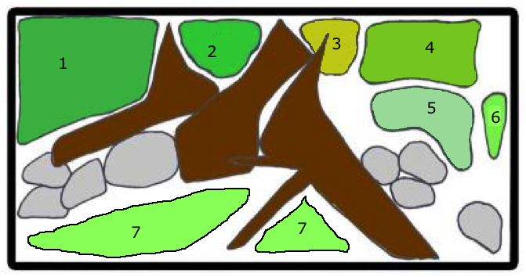

Planting Plan.
1. Vallisneria (Vallisneria nana),
2. Pogo (Pogostemon stellatus),
3. Willow Hygro (Hygrophila angustifolia),
4. Native Ambulia (Limnophila brownii or L.australis),
5. Native Rotala (Rotala mexicana),
6. Staurogyne (Staurogyne leptocaulis).
7. Nardoo (Marsilea angustifolia)
A large Ottelia alismoides or Aponogeton as a feature plant will also add to the aesthetic nature of the aquarium.
Floating on the surface is Giant Duckweed (Spirodela polyrhyza).

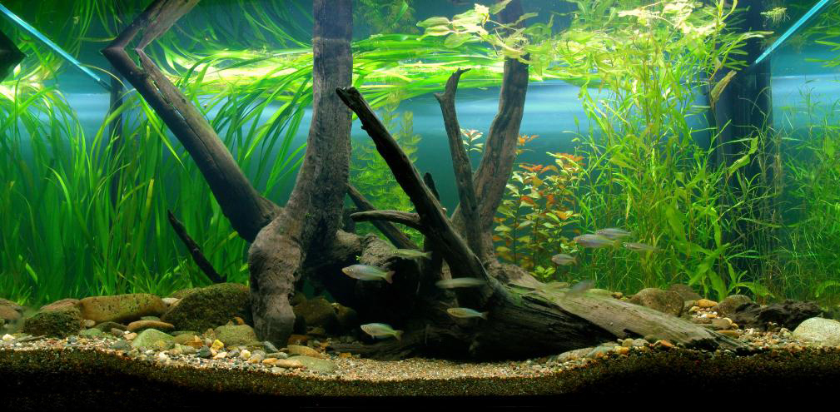
Photograph by Shane Brooks. This is an aquarium that won an international competition. It was called the Billabong Aquarium.

Fish

The aim of the species selection is to obtain a community of fish, crustaceans and invertebrates that get along together. The fish from the Mary River are listed below and because of their peaceful nature and non predatory habits. Some fish are small and vegetarian but aggressively defend a patch of space by chasing all the other fish away. Some fish are just too large and require either their own aquarium or an aquarium that is too big to be practical.

Foods and feeding - The small fishes in the aquarium are termed forage fishes and are omnivores taking small aquatic and terrestrial invertebrates and some algae in their diet. The smaller shrimps are algae eaters mainly but will also clean up any left overs from the small fishes. The snails will help with this as well. These small scavengers are part of the small ecosystem and are the clean up crew.

The fish can be fed a daily mix of crushed aquaculture pellets and will do better with a weekly or twice weekly feeding of live foods such as Moina, Daphnia, mosquito larvae or some other small invertebrate. There are also foods that can be made up using food items from the supermarket and a blender. These foods are better for the fishes than the convenient aquaculture crumble.

One recipe that has been used very successfully is called “Pea and Prawn Puree”
Ingredients - 30% raw prawn, 30% fish fillet, 40% peas, zucchini, carrot, and corn kernels. combined with 10 grams of calcium ascorbate per kg mince.

Method

Freeze all ingredients in chunks that will fit in mincer throat. Put frozen ingredients through hand mincer (2 or 3 mm plate) and make into a thick slurry. Mix 10 grams of calcium ascorbate (non acidic vitamin C) through mix. Place mix in plastic bags. Flatten mince till it is about one centimeter thick. Place plastic bags in freezer. When food is needed break portions from frozen slab. Feed sparingly as it will pollute the water much more readily than flake foods.

Spotted Blue-eye, Pseudomugil gertrudae - suitable for the community aquarium 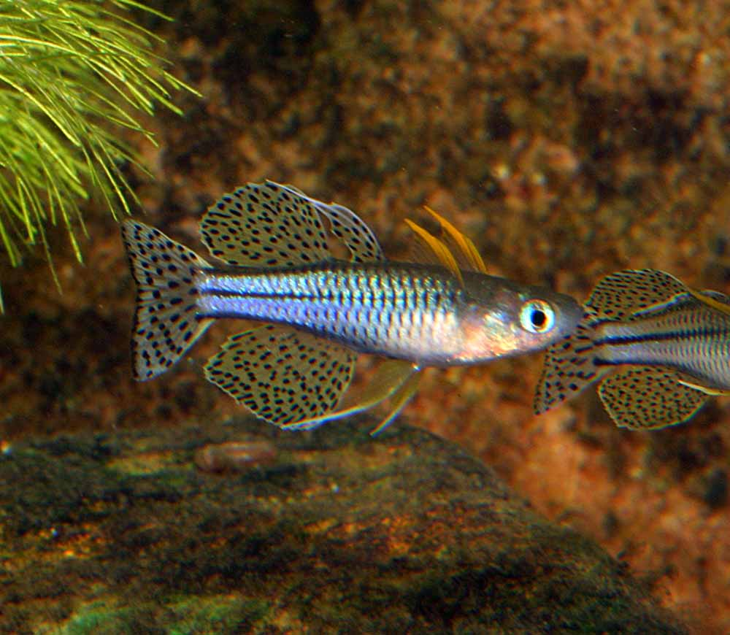

Delicate Blue-eye, Pseudomugil tenellus - suitable for the community aquarium
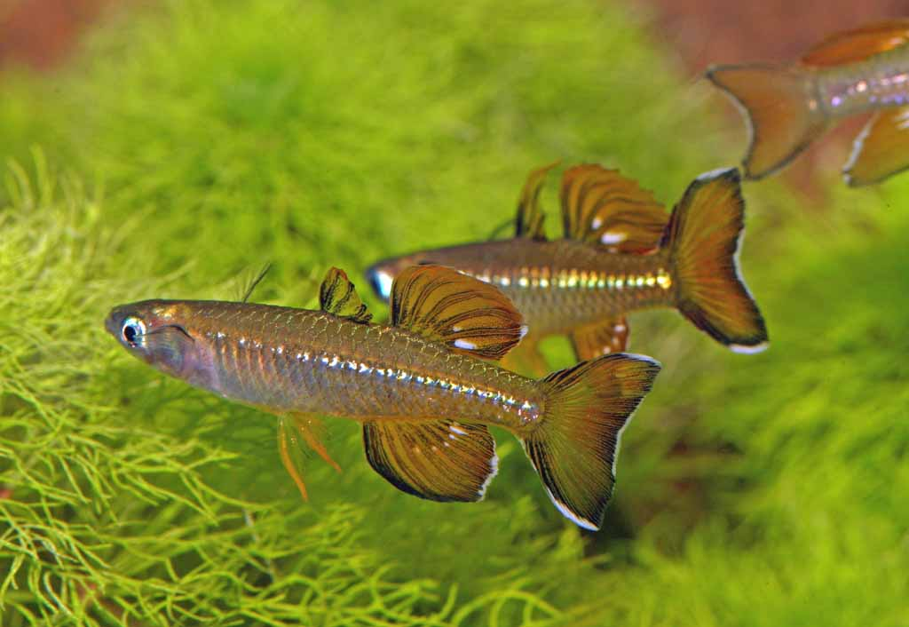

Penny Fish, Denarusia bandata - suitable for the community aquarium
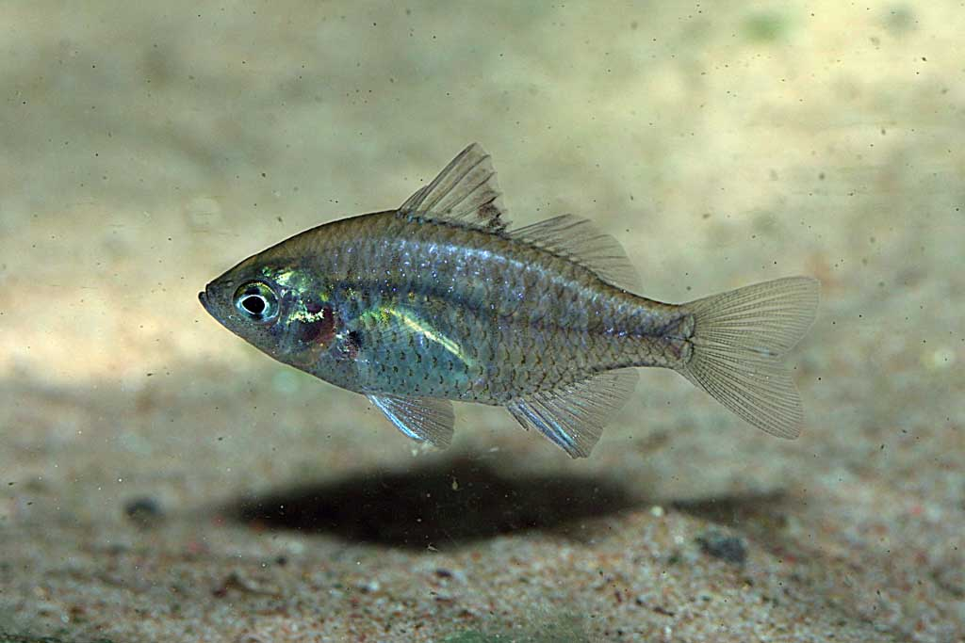

Sailfin Glassfish, Ambassis agrammis - suitable for the community aquarium
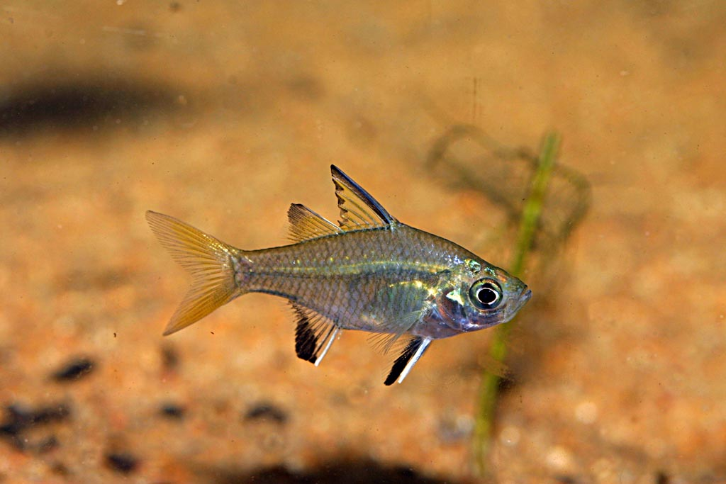

Exquisite Rainbowfish, Melanotaenia exquisita- suitable for the community aquarium
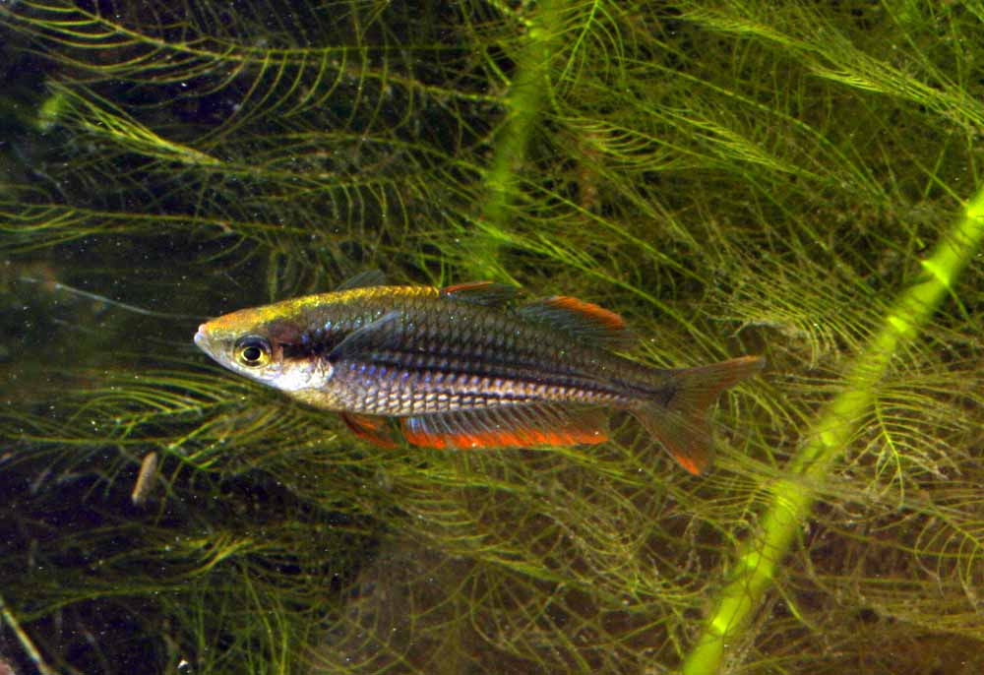

Blackbanded Rainbowfish, Melanotaenia nigrans – suitable for the community aquarium
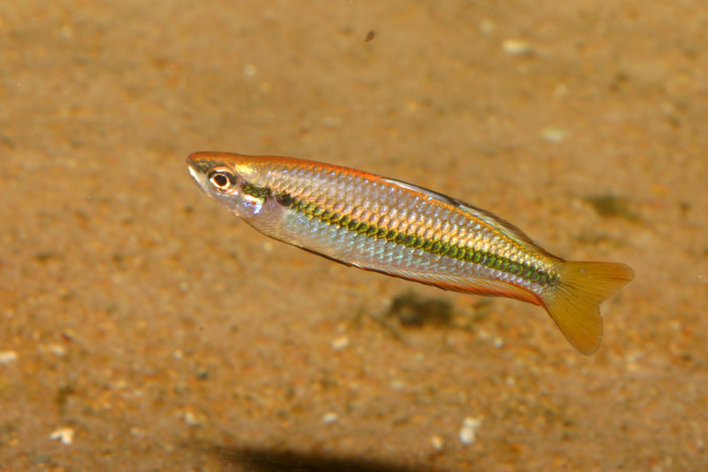

Banded Rainbowfish, Melanotaenia trifasciata - suitable for a community aquarium
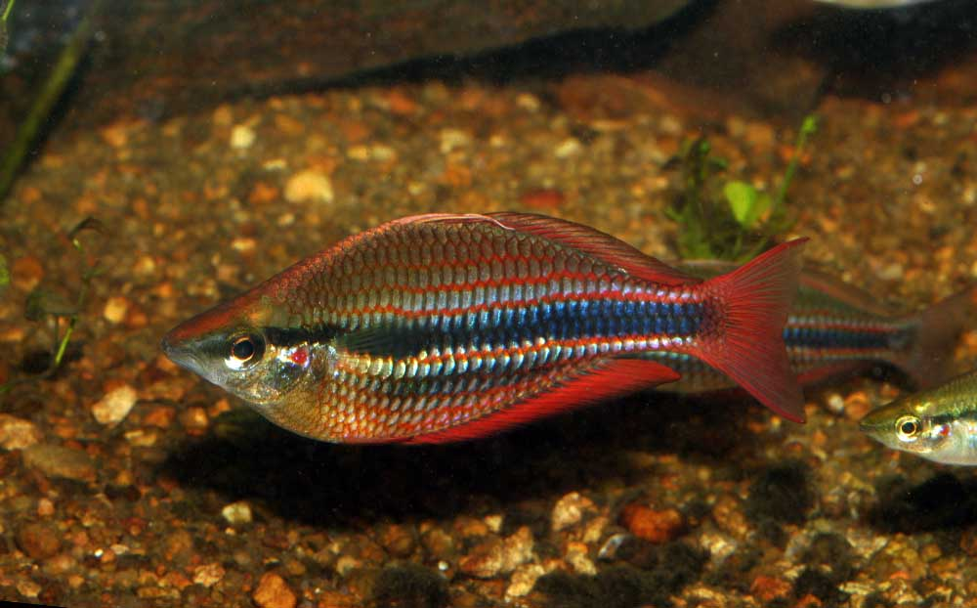

Chequered Rainbowfish, Melanotaenia splendida inornata - suitable for a community aquarium
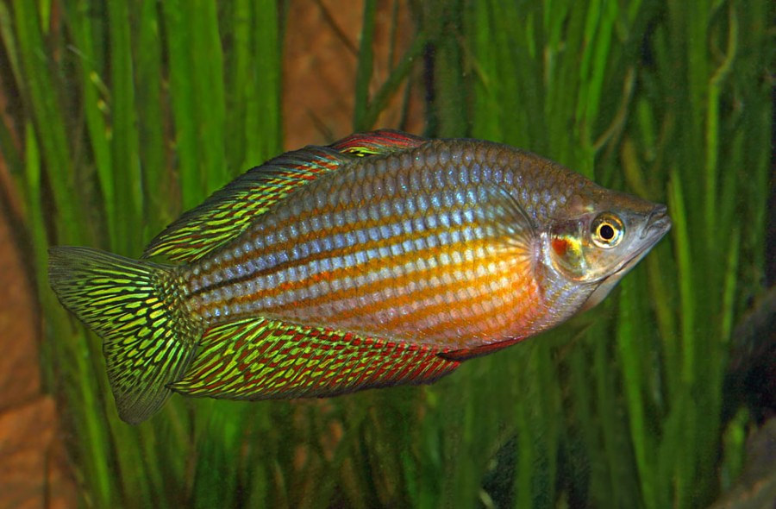
Flyspeck Hardyhead, Craterocephelus stercusmuscarem – eats algae and is good in the aquarium
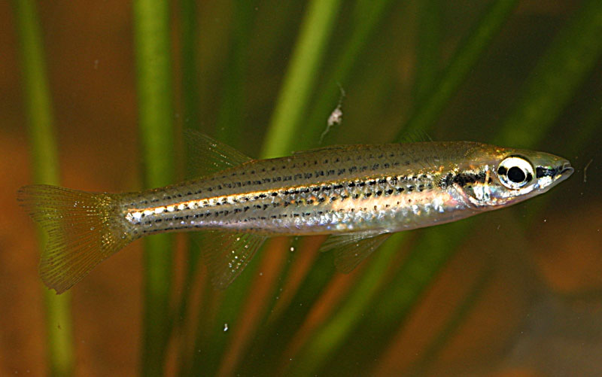

Other fishes considered for the Aquarium.

Reticulated Glassfishes, Ambassis macleayi – can grow a little large and eats small fish
Sleepy Cod Oxeleotris lineolatus - Not suitable too large and a predator
Giant Gudgeon Oxeleotris selheimi - Not suitable too large and a predator -
Flat Headed Goby Glossogobius giurus - Not suitable too large and a predator
Golden Goby Glossogobius aureus- Not suitable too large and a predator
Rendahl’s Catfish Porochilus rendahli - Not suitable too large and a predator
Hyrtles Catfish Neosilurus hyrtlii - Not suitable too large and a predator
Black Catfish Neosilurus ater- Not suitable too large and a predator
Blue Catfish Neoarius graffei- Not suitable too large and a predator
Salmon Catfish Neoarius leptaspsis - Not suitable too large and a predator
Flatheaded Catfish Neoarius midgleyi- Not suitable too large and a predator
Barramundi Lates calcarifer- Not suitable too large and a predator
Bony Bream Nematalosa erebi- Not suitable too large
Longtom Strongylura kreftii- Not suitable too large and a predator
Mouth Almighty Glossamia aprion- Not suitable too large and a predator
Barred Grunter Amniataba percoides- Not suitable too large and a predator
Butlers Grunter Syncomistes butleri - Not suitable too large
Coal Grunter Hephaestus carbo - Not suitable too large and a predator
Spangeld Grunter Lerioptherapon unicolor- Not suitable too large and a predator
Sooty Grunter Hephaestus fuliginosus - Not suitable too large and a predator
Saratoga Scleropages leichardti - Not suitable too large and a territorial predator
Purple Spotted Gudgeon Mogurnda mogurnda - can grow large and eat smaller fishes.

Invertebrates

Snails – Essington Snail Notopala essingtonensis
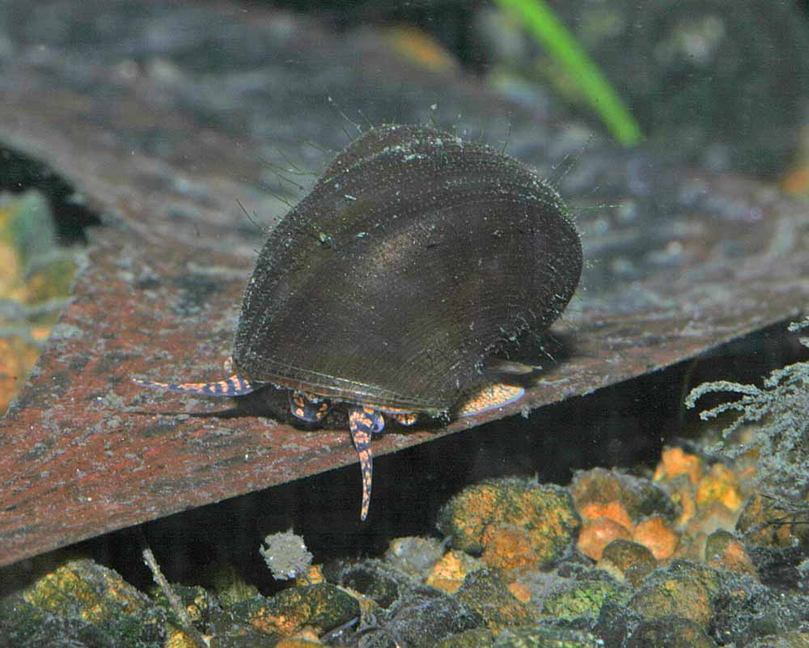

Shrimps – Darwin Algae eating shrimp Caridina sp.
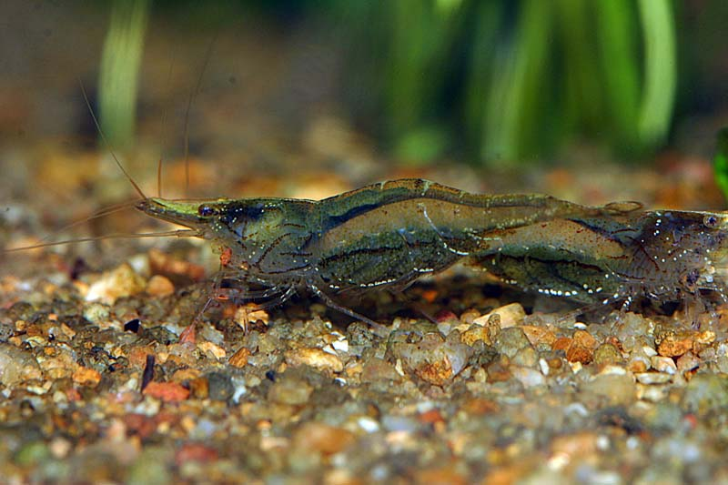
River Prawns
Handschin’s River Prawn Macrobrachium handschini - The smallest and a harmless river prawn
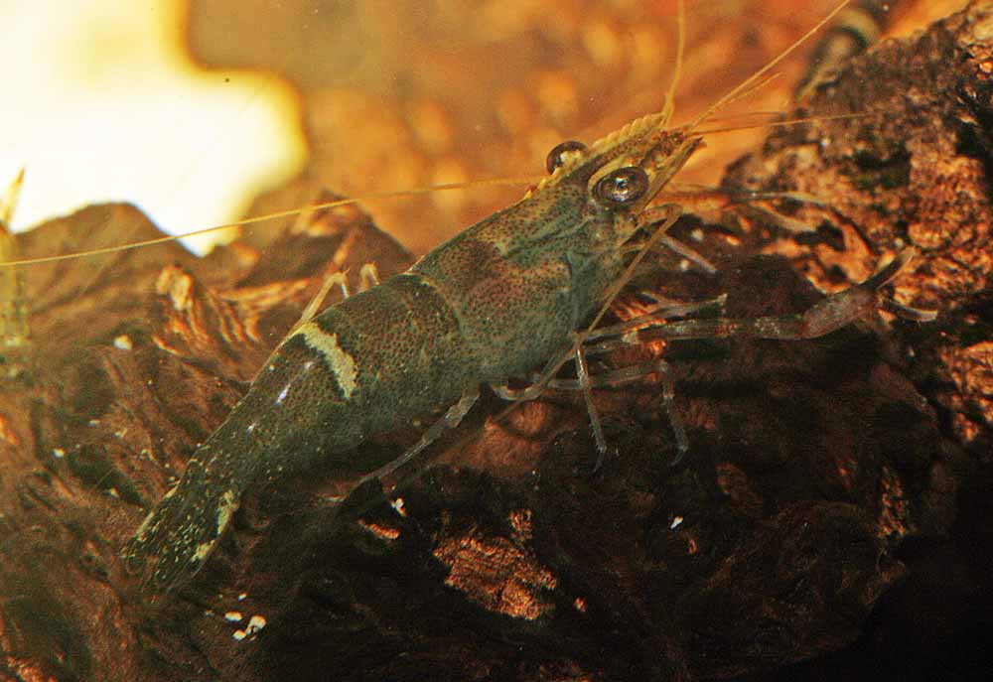

Maintenance Plan

Feeding Fish
Feed fish only as much as they can eat once a day. Try not to let much food onto the bottom of the aquarium but watch carefully to make sure all the fish get some food.

Fertillising plants
Follow the schedule outlined with the exstimative index method.
Water Change weekly maintenance procedure.
- Turn off all the power except the lights.
- Clean the viewing glass.
- Remove any dead leaves, trim plants where required.
- Use gravel siphon to remove detritus.
- Refill aquarium with prepared dechlorinated water.
- Turn on the power and make sure the filter and everything is running.
- Prepare water for next week water change.

Equipment required:
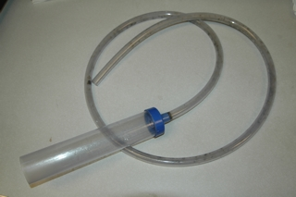
Gravel cleaner, siphon

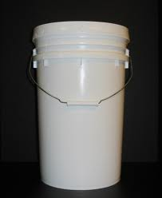
A bucket

Management records – Task allocation

The keeping of an aquarium in a public area where there is more than one person performing management tasks requires the need for a good communication system to be in put in place. This will allow the operators to know all that has been done to the aquarium. To achieve this, the best way is to use a roster of personnel accompanied by proper use of records that will keep all informed by a quick glance in the Aquarium Diary.

The use of a spread sheet in on a computer is OK acceptable. There are aquarium maintenance programs for Mac and PC available now and there will probably be an app available in the near future for tablets and smart phones soon as well.

Problem Solving

A good maintenance plan with attention to water quality, peaceful community make up of life forms, places for aquatic life to hide and a correct diet will produce a beautiful aquarium to enjoy. By providing these simple requirements you can have an aquarium with very few problems. The only exception is the possibility of over population of plants and animals that can be easily solved by pruning and culling.

However, if the fish or other invertebrates become unwell then there is an approach to problem solving. Before anything is put together, all fish and invertebrates should be quarantined. This means that they should go through a period of two months in a separate place where any problems can be observed and dealt with via treatment.

2 Month Quarantine – The keeping of all plants and critters in a separate place to make sure there are no diseases or parasites that will over run the display aquarium. There are many fish treatments available, but general treatments in a quarantine set up will involve some broad spectrum techniques. These broad spectrum techniques will fix most problems that wild fish have, which are mostly ectoparasites, such as gill flukes, skin flukes and fish lice. Other problems are caused by protozoa with a few nasty ones common in NT Rivers and billabongs.

The treatments for these fish ailments can kill water plants and invertebrates so it is best to keep new critters in a separate smaller tank for two months prior to adding to the main display aquarium.

However, if after all the precautions have been adhered to and some well meaning know it all sabotages your quarantine protocols by putting some little fish they caught down at the creek on the weekend into your clean and well maintained aquarium and all your fish get sick. The best thing you can do first is deal with your well meaning friend so they don’t do it again, then look up a good reference on what to do about your sick fish.

The first sign that something is wrong in your aquarium is usually observed as a change in fish behaviour. Once you know your fish and what they do each day, then changes in behaviour will be quite obvious. An example of this is fish swimming to an object and darting across it like they are scratching themselves. This is a sign they may have a protozoan parasite infection.
Unwell fish may also have a different appearance on their skin. They will probably become less active and hide away in the plants, perhaps with their fins clamped against their body. This may be a sign of a protozoan infection, especially if the skin looks a little milky or has some white spots developing. This can be treated by dosing salt initially or with an industrial dye, such as malachite green mixed with formalin. These will kill off the protozoan but this must be repeated over a period of time because some of the protozoans have a life stage that is impervious to anything.

There are many other ailments that affect fish and crustaceans that are best eliminated at the quarantine stage. It is best to refer to a vet or get a diagnosis from an experienced fish disease person. There is a fish pathologist at the NT Fisheries Department and you may be able to get a diagnosis for a fee. Vets usually don’t know about fish diseases. Dr Steven Cutter, local area vet in Palmerston, NT, is experienced with fish disease diagnosis. Treating for the wrong ailment can kill your fish.

References and further reading

Allen, Midgley & Allen (2002) “Freshwater Fishes of Australia”

Cowwie, Short & Osterkamp-Madsen, (2000) “Floodplain Flora”

Cronk & Fennessy (2001) “Wetland Plants, Ecology and Biology”

Kasselmann (2003) “Aquarium Plants”

Larson & Martin (1989) “Freshwater Fishes of the Northern Territory”

Leggett & Merrick, (1987) “Australian Freshwater Fishes for Aquariums”

Noga (2000) “Fish Disease, Diagnosis and Treatment”

Satoshi & Kobayashi, (1993) “The Natural Aquarium”

Spotte (1992) “Saltwater Aquariums, Science and Technology”

Walstad (1999) “The Ecology of the Planted Aquarium”

Williams (1980) “Australian Freshwater Life”

Appendix 1
Maintenance Schedule
EI dosing

Plant growing using the Estimative Index (EI)
EI dosing fertilisers for 450 litre planted aquarium low light -

To reach your target of 10 ppm NO3 you will need to add 7.337 g KNO3, Potassium nitrate to your 450.0 L aquarium to yield
Element | ppm/degree
K | 6.31
N | 2.26
NO3 | 10.00

To reach your target of 1 ppm PO4 you will need to add 644 mg KH2PO4, Monoammonium Phosphate to your 450.0 L aquarium to yield
Element | ppm/degree
K | 0.41
P | 0.33
PO4 | 1.00

To reach your target of 15 ppm Ca you will need to add 31.063 g CaMg(CO3)2 Dolomite to your 450.0 L aquarium to yield
Element | ppm/degree
Ca | 15.00
Mg | 9.10
dGH | 4.18
dKH | 4.20
To reach your target of 5 ppm Mg you will need to add 22.817 g MgSO4.7H2O to your 450.0 L aquarium to yield
Element | ppm/degree
Mg | 5.00
S | 6.60
dGH | 1.15

To reach your target of 10 ppm K you will need to add 10.028 g K2SO4 to your 450.0 L aquarium to yield
Element | ppm/degree
K | 10.00
S | 4.10

To reach your target of 0.2 ppm Fe you will need to add 1.5 g Rexolin APN to your 450.0 L aquarium to yield
Element | ppm/degree
B | 0.04
Cu | 0.01
Fe | 0.20
Mn | 0.08
Mo | 0.01
Zn | 0.04

Preparation of Stock EI dosing solutions
A small kitchen scale or some tiny measuring spoons will be sufficient. The stock solutions can be mixed in a bottle or a jug and added all in one lot but the chelated micronutrients.

Monday
Feed fish
Dose Chelated trace elements, 1.5 g Rexolin APN brand

Tuesday
Feed fish
Dose EI nutrients
7.337 g KNO3 potassium nitrate
644 mg KH2PO4 monopotassium phosphate
10.028 g K2SO4 potassium sulphate
31.063 g CaMg(CO3)2 dolomite Lime
22.817 g MgSO4.7H2O magnesium sulphate

Wednesday
Feed fish

Thursday
Feed fish

Friday
Feed fish
50% Water Change
Test water quality, make adjustments, note on diary

Water Quality Tests and Adjustments.
The water quality tests that are required are:
Hardness – use an Aquasonic test kit and make a record of the hardness level indicated. A target level of 70 ppm is desirable and the weekly addition of the 30 grams of dolomite should keep the levels up. If it does not then the weekly dose could be increased slightly.
Alkalinity ( also known as Carbonate Hardness and Acid Binding capacity) - The level of carbonates is measured with an Aquasonic test kit. The desired level is 80ppm and can be increased by adding 9 grams of potassium bicarbonate to a 450 litre aquarium to achieve a 10ppm rise in the level. The rule is that 20 grams of potassium bicarbonate in a ton of water (1000 litres) will raise the carbonate hardness or alkalinity by 10 ppm.

Temperature - Keep between 25 and 30 Deg C. That should be the temperature in the general area where the aquarium is located. If the temperature goes past the upper or lower levels on a regular basis you may need to add a heater or chiller.

pH – the best pH is about neutral or 7.0. It may go a little higher which will be okay but if it gets below 6.5 then add some potassium bicarbonate to increase alkalinity to 80 ppm will most likely adjust it correctly.

Saturday and Sunday
No need to feed fish but if someone is present feeding will be OK. Going without food over the weekend won’t hurt the fish.

Appendix 2
Aquarium - 450 litre Native Planted Biotope
Date | Time | Temp | Alk | GH | pH | Comments and operators name

